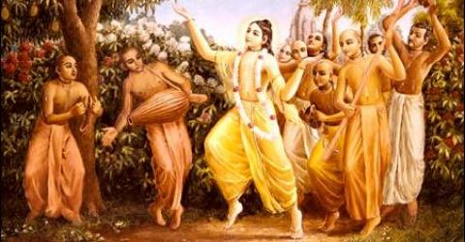

August 2010 Edition
www.soldiersofgodhead.yolasite.com
Contents
Sr.no Topic Pg.no
- The Glories of Krishna Prasadam. 3.

- Making your home a temple. 8.

- Celebrating Janamashtami. 14.

- The Glories of Krishna Prasadam

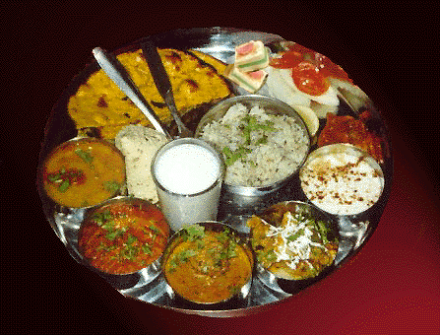

Krishna Prasadam is any pure vegetarian food offered to the Lord before being eaten. This process of offering food to the Lord or Bhog sanctifies the food and the one who eats the remnants of the food sanctified by Lord Krishna becomes free from any evil effects of his misdeeds and develops pure love for Krishna. When one cooks food for his own enjoyment, that food becomes contaminated and the one who eats such food becomes a sinner. However, when one cooks for the Lord’s enjoyment, such food becomes sanctified and free from any contamination and sins. In fact the one who eats such sanctified food becomes a fit candidate to go back home, back to godhead. Hence, cooking is an important and integral aspect of Krishna Consciousness.
In Srimad Bhagavatam, there is a story about Narada Muni ( the messenger of the demigods) and how he became a pure devotee of the Lord simply by eating prasadam. He was cursed to be born on earth (mrtyuloka) in the house of a poor woman. His mother though poor, would daily feed the brahmanas who would come to her village. The brahmanas did not accept any food other than Krishna prasadam. Hence, she would serve them with prasadam on a daily basis. Narada Muni would eat the leftovers of the brahmanas. But eventually after eating the remnants of the foodstuff offered to the devotees of the Lord, he too developed true love for the Lord and became a highly advanced devotee who could never cease chanting the glories of the Lord. Through this story we can understand the potential of Krishna Prasadam. Another point worth noting is that although the food sanctified by the Lord is universally beneficial, the remnants of foodstuff eaten by the Lord’s true devotee is even more beneficial. Hence, Krishna Prasadam is called Maha Prasadam and the remnants of foodstuff eaten by His true devotee is called Maha Maha Prasadam.
Hence, one should never accept any food other than Krishna Prasadam or the food eaten by His true devotee. But what is the process of making food sanctified? And which foodstuffs can be offered to the Lord? These are certain questions that need to be answered for obtaining the complete benefit of Krishna Prasadam. In the Bhagavad Gita Lord Krishna says in chapter 9 text 26, patram puspam phalam toyam yo me bhaktya prayachayati (When one offers me with devotion even a leaf, fruit, a flower or a little water, I will accept it.) Here the leaf refers to the Tulsi leaf. The Lord does not need any food or offerings in reality. But He is so kind upon His devotees, that He accepts anything we offer Him with true love and devotion. Hence, whatever we offer to the Lord must be love and devotion and without any expectation of material benefits. The Lord does not ask for abominable things like meat, wine or any impure or intoxicating things. He accepts only satvik (pure) things like leaves, fruits, flowers, grains, vegetables, pulses etc. (One must not offer onion, garlic, masur dal, or anything containing caffeine to the Lord as they are not considered pure vegetarian) The Lord does not accept even pure offerings if they are offered without a Tulsi leaf or without love and devotion. Hence, the offerings must be accompanied by at least one tulsi leaf and must be offered with pure love and devotion.
One can offer foodstuffs to the Lord’s image/picture or to the deity. It does not make a difference if the food is offered to the picture or deity of the Lord, as both are the Lord’s archa vigraha forms or the form the Lord takes in order to accept the services of His devotees. One must take bath and put on clean clothes before entering into the kitchen. He/she must clean all the vessels in which the food is to be cooked and offered. Only pure vegetarian ingredients must be used for cooking. The food must be cooked keeping the Lord in mind and only for His satisfaction and enjoyment. The food must be garnished with Tulsi leaves and must be kept before the Lord and the devotee must request the Lord to accept his humble services and sanctify the food. After the food is sanctified, it must be distributed among all assembled devotees.
In this way one must serve the Lord and develop pure love for Him. Distribution of prasadam is hence considered an effective way of developing devotion in the hearts of non-devotees. Note that prasadam refers not only to temple food but to any pure vegetarian food offered to the Lord. Hence, it can and should be prepared at home of everyone.

Hare Krishna!
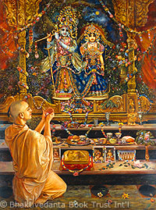

- Making your home a temple.

“What is the difference between a home and a temple?” This was a question put forth by a devotee to Srila Prabhupada in New York in the year 1967. Srila Prabhupada replied, “At home you serve your own senses and at the temple you serve Krishna’s senses.” Through this reply of Srila Prabhupada, we can clearly understand the distinction between “a home” and a “temple”. So what can be done to make a home into a temple? Yes. By engaging our senses in serving the senses of the Lord, we can convert our homes into Krishna temples! Rather than doing things like cooking, cleaning etc for our own satisfaction, we can do the same for Krishna’s satisfaction. By serving the picture or deity of the Lord, we can render personal service to Him even at home. Hence, it is essential to have an altar for the Lord at home. One can even have an entire room of the house dedicated to the Lord. Such rooms are called temple rooms or puja rooms.
Maintaining a spiritual environment at home is very essential, especially in the modern days of stress and depression. In order to spiritualize the house, one must maintain utmost cleanliness of the house and all unnecessary articles must be discarded. No non-vegetarian food should be taken by any member of the family. In fact such abominable food should not even be allowed to be kept in the house. All members of the family must maintain their external as well as internal cleanliness. External cleanliness can be achieved by bathing at least twice daily (morning and evening) and internal cleanliness can be easily achieved by chanting Hare Krishna Hare Krishna Krishna Krishna Hare Hare/ Hare Ram Hare Ram Ram Ram Hare Hare and daily reading the Bhagavad Gita. All members of the family must follow the four regulative principles as laid down by Srila Prabhupada:-
- No meat eating
- No smoking, drinking or drugs
- No illicit sex
- No Gambling
When all the members of the family follow these regulative principles and chant Hare Krishna and read the Bhagavad Gita on a regular basis, they shall purify their existence and a spiritual and blissful atmosphere shall exist at home.
The purpose of establishing a spiritual environment at home is to engage the family members in the discharge of devotional service to Lord Sri Krishna. Every morning and evening, all members should bathe and put on clean clothes and assemble in the temple room or before the altar of the Lord to discharge devotional service and chant the glories of the Lord. Chanting Hare Krishna Hare Krishna Krishna Krishna Hare Hare/ Hare Ram Hare Ram Ram Ram Hare Hare is the best as it is recommended for this present age of Kali or Kalyuga. Chanting the glories of the Lord is the easiest and also the recommended method for discharging devotional service to the Lord. Harer nama harer nama harer namaivam kevalam, kalau nasty eva nasty eva nasty eva gatir anyatha. “‘In this Age of Kali there is no other means, no other means, no other means for self-realization than chanting the holy name, chanting the holy name, chanting the holy name of Lord Hari (Krishna) Chaitanya Charitamrita, Adi Lila 17.22. The above verse describes the significance of the chanting process. When one chants the glories of the Lord, he develops a liking for it. Just like milk turns into curd, eventually this liking also develops further into pure love for God. In the present age of Kali, there is no other means to attain salvation, moksha or freedom from the cycle of birth, death, old age and disease. Hence, one must regularly and in the company of devotees, chant the glories of Lord Sri Krishna the supreme personality of godhead.
How can one attain salvation from merely chanting the names of God? This is an obvious question that may arise in one’s mind, because we know how hard some yogis, rishis and other renounciates do austerities to attain salvation and yet they meet with so many difficulties. There are people who worship so many demigods like Shiva, Brahma, Ganesha etc, but still face so many difficulties. So how can one simply by chanting Krishna’s name attain that difficult goal? The time of death is a very important moment. The state of mind in which one leaves his body at the time of death, the same form of life he attains in his next life. So if one is thinking of material things while leaving his body for example, his wealth, property, family, friends etc. he is going to take another birth in accordance to his karma and desires for sense gratification. This process goes on and on and in this way one remains stuck in this cycle of birth and death. However, if one is able to think of Krishna or even by mistake take his name while leaving his body, he never returns to this material world again and goes back home, back to godhead to His abode, Goloka Vrindavan. But, it is not easy to think of someone or something at the time of death since one may be facing pain, fear of disassociation with loved ones, and a desire to continue to live. Hence it is not an easy task to remember Krishna at the time of death. In order to be able to do this, one must practice constant chanting of the Hare Krishna Maha Mantra as propagated by Lord Sri Chaitanya Mahaprabhu (Lord Krishna’s form in Kaliyuga). This is the most easiest and cheapest of all methods as there are no hard and fast rules. Anyone can chant it at any time at any place while doing absolutely anything.
Hence, the purpose of spiritualizing the house is to make it possible for all family members in the house to be able to become Krishna Conscious and think of Krishna at the time of their death. However, the significance of the chanting process is not limited to attaining liberation. The most important benefit of it is that one develops true love for Krishna and becomes His true devotee and attains freedom from lust, anger and greed and all other vices. Hare Krishna!
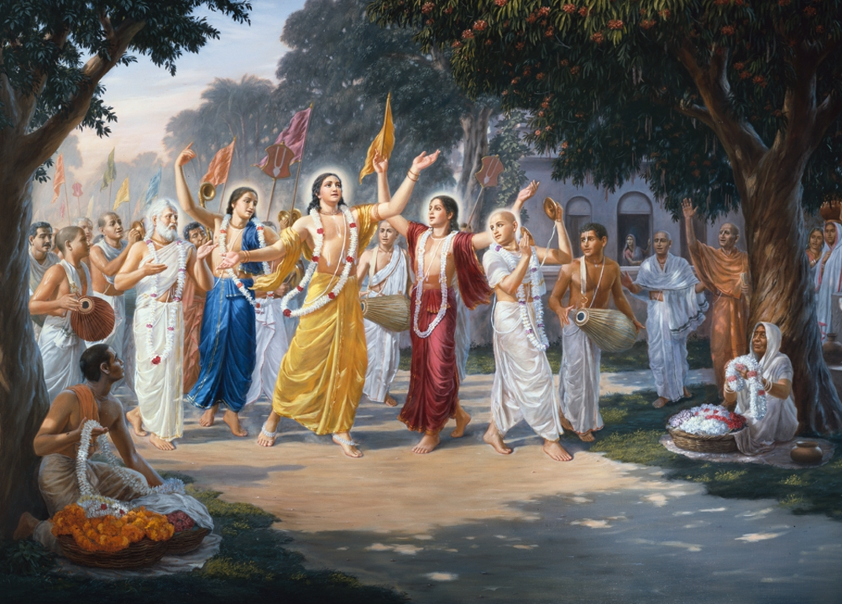
Lord Chaitanya Mahaprabhu conducting Sankirtana
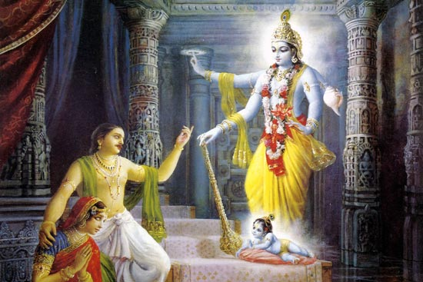
When Lord Krishna appeared before Devaki and Vasudeva, he appeared in His four armed form and at their request, took the form of an infant.

- Celebrating Janmashtami

Janmashtami is the appeareance day of Lord Krishna in this material world for the establishment of religious principles and deliverance of His devotees. This day is not exactly His birthday since the Lord is aja (unborn). He appeared on this day and hence it is celebrated as His appearance day by Vaishnavas.
Janmashtami is also known as Krishnashtami, Gokul Ashtami, or Ashtami Rohini since He appeared in the Rohini Nakshatra . Krishna Janmashtami is observed on the Ashtami tithi, the eighth day of the dark half or Krishna Paksha of the month of Shravaana in the Hindu calendar, when the Rohini Nakshatra is ascendant. The festival always falls within mid-August to mid-September in the Gregorian calendar. This year Krishnashtami is being celebrated on 2nd of September.
Lord Krishna was the 8th child of Vasudeva and Devaki. Devaki’s brother Kamsa was a highly immoral man and the king of Mathura. He had received a divine message that he would be killed at the hands of the eighth child of his sister Devaki. So he immideately imprisoned his sister along with her husband, Vasudeva. One by one he would kill their children as they would be born. In fact as a preventive measure, he issued an order for all infants within his kingdom to be killed. As a result, many innocent children were killed by the soldiers of kamsa. After seven children of Devaki and Vasudeva were killed, Lord Krishna appeared before them in His chturbhuja (four hand) form. They requested Him to take the form of an infant and so the Lord took the form of a new born child. Then, all the chains with which Devaki and Vasudeva were tied became loose and all the prison guards became temporarily paralyzed. The prison doors opened by themselves and Vasudeva in an unconscious/ hypnotized state, took Lord Krishna in a basket and carried the basket on his head out of the prison and took Him to the village Gokul, near Vrindavan. It was a dark night with heavy rainfall. In order to reach Gokul, he would have to cross the Yamuna river. So carrying the Lord on his head, he crossed the river with his entire body except his head immersed in the water. In order to “protect” the Lord from the heavy rain, the Lord’s devotee sheshanaga appeared and covered the Lord with his multi hooded head, so that the Lord is not inconvenienced from the rain. On reaching Gokul, Vasudeva went to the home of Nanda Maharaj and replaced his newborn daughter who was born on that very night, with Lord Krishna. He then took the infant girl along with him back to the prison cell. When Kamsa came to know of the 8th child being born of Devaki, he came to kill the child. When he lifted the infant girl to throw her and kill her, she took her real form of the Goddess Durga and informed Kamsa that the one who is destined to Kill him has already appeared in this world!
In this way, Lord Krishna appeared in this world to annihilate the miscreants and establish the principles of religion. Janmashtami is celebrated all over India and also all over the World in all Hare Krishna temples. This is the most significant Vaishnava festival, since it is the day on which our beloved Lord appeared for the deliverance of all of humanity and to show us the path to go back home, back to godhead.
It is very simple to celebrate Janmashtami and anyone and everyone can celebrate it at home or in Krishna temples. Firstly, one must wake up early in the morning and take bath and put on clean clothes. Clean and decorate the Lord’s altar or the temple room. Decorate the picture of the Lord with a garland of flowers, do arati, offer incense and freshly prepared sweets to the Lord. In case of a deity, decorate the Lord with new clothes. Offer tulsi leaves to the Lord (but not to Radharani), chant hare krishna and conduct Bhagavad Gita discourses. One must keep fast on the day on Janmashtami till midnight and then celebrate with a feast of prasadam.
In India it is a common practice to hang Dahi Handies (pots filled with butter or curd) at a significant height and young boys form a sort of human pyramid and the one at the top of this human pyramid breaks the dahi handi. In this way the lord’s past time of stealing butter is recreated by His devotees.

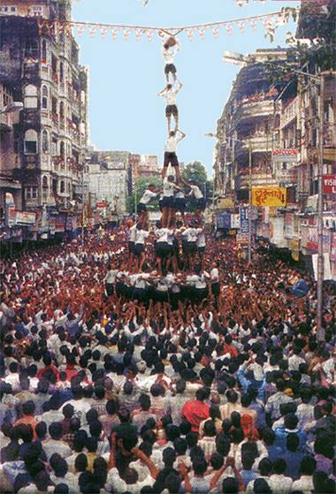
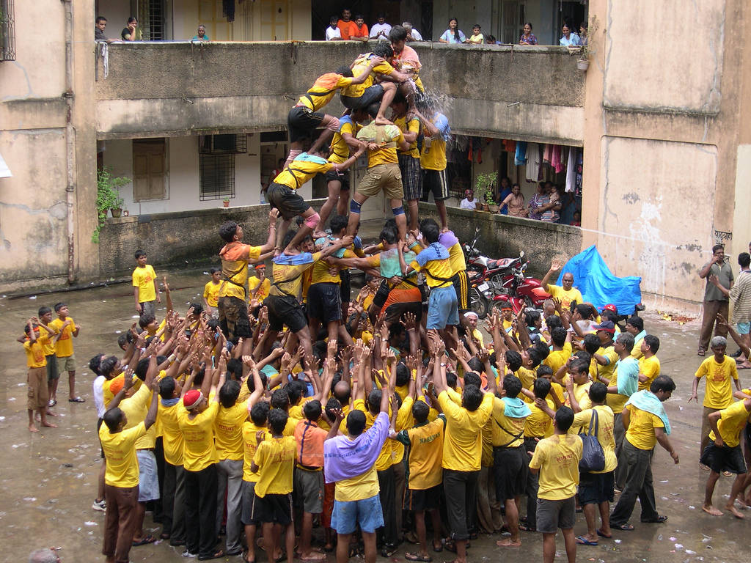
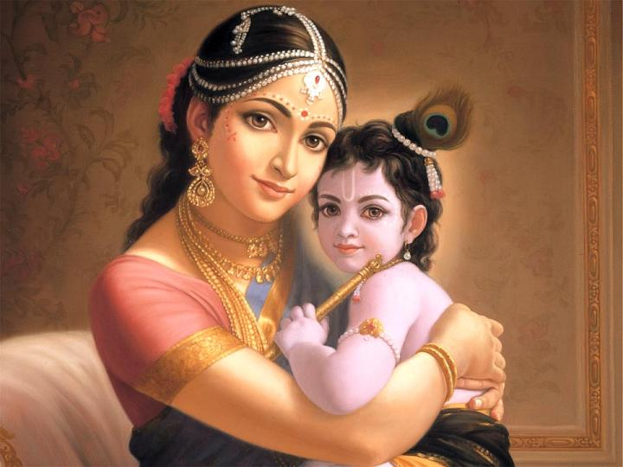

Lord Krishna in the arms of Mother Yashoda.
One must fast till midnight on Janmashtami, chant the glories of the Lord and read sacred scriptures like Bhagavad Gita and the Bhagavad Puran in the association of devotees. The one who observes fast on this day and offers his services to the Lord, certainly develops devotion and becomes a fit candidate to go back home, back to godhead.

Hare Krishna!

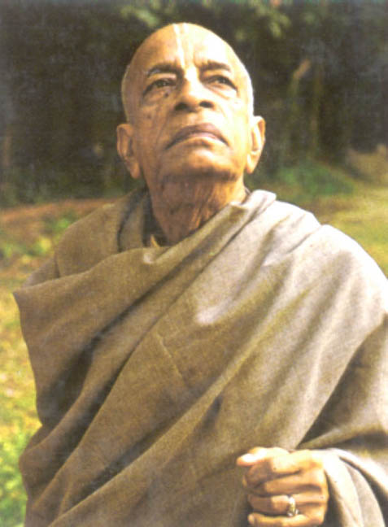

Dedicated to Lord Sri Krishna and His Divine Grace A.C. Bhaktivedanta Swami Prabhupada, founder Acharya of the International Society for Krishna Consciousness.
Written, Edited, Published and Distributed by,
Govardhanagirivaradhari Dasa (Vinay.D.Chakraborty)

For receiving free monthly editions, write into:
Vinay.chakraborty@yahoo.com
Or visit: www.soldiersofgodhead.yolasite.com

Related Sites:
www.VaishnavaTV.yolasite.com
www.SSRRET.yolasite.com

Do send us your views, comments, suggestions and queries.

Hare Krishna!

